PROCLAMATION from the
Office of the Mayor
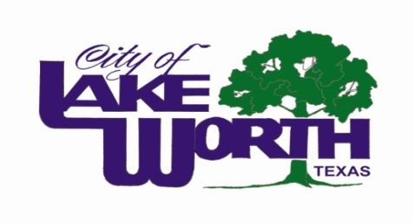

Whereas, blood cancers currently afflict more than one million people in the United States, with an estimated 175,200 new cases diagnosed each year; and
Whereas, leukemia, lymphoma, and myeloma will kill an estimated 52,560 people in the United States this year; and
Whereas, The Leukemia & Lymphoma Society (LLS), through voluntary contributions, is dedicated to finding cures for these diseases through research efforts and the support for those that suffer from them; and
Whereas, LLS maintains an office in Dallas and Fort Worth to support patients with these diseases and their family members in the State of Texas.
Now, therefore, I, Walter Bowen, Mayor of the City of Lake Worth, do hereby declare that the City of Lake Worth joins with LLS in designating the month of September 2015 as “Blood Cancer Awareness Month” to enhance the understanding of blood related cancers and to encourage participation in voluntary activities to support education programs and the funding of research programs to find a cure for them.
Proclaimed this 11th day of August 2015.

Walter Bowen, Mayor

