PROCLAMATION from the
Office of the Mayor
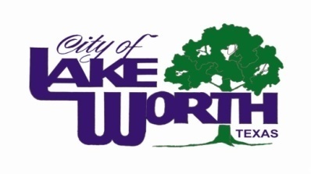
WHEREAS, our state’s continuing efforts to address the critical issues of safety, energy efficiency, water conservation and sustainability in the built environment that affect our citizens, both in everyday life and in times of natural disaster, give us confidence that our structures are safe and sound; and

WHEREAS, our confidence is achieved through the devotion of vigilant guardians—building safety and fire prevention officials, architects, engineers, builders, laborers and others in the construction industry—who work year-round to ensure the safe construction of buildings; and

WHEREAS, these guardians—dedicated members of the International Code Council—develop and implement the highest-quality codes to protect Americans in the buildings where we live, learn, work, worship, play; and

WHEREAS, the International Codes, the most widely adopted building safety, energy and fire prevention codes in the nation, are used by most U.S. cities, counties and states; these modern building codes also include safeguards to protect the public from natural disasters such as hurricanes, snowstorms, tornadoes, wildland fires and earthquakes; and

WHEREAS, Building Safety Month is sponsored by the International Code Council and International Code Council Foundation, to remind the public about the critical role of our communities’ largely unknown guardians of public safety—our local code officials—who assure us of safe, efficient and livable buildings; and

WHEREAS, “Building Safety Month: An International Celebration of Safe and Sensible Structures” the theme for Building Safety Month 2011, encourages all Americans to raise awareness of the importance of building safety; green and sustainable building; pool, spa and hot tub safety; and new technologies in the construction industry. Building Safety Month 2011, encourages appropriate steps everyone can take to ensure that the places where we live, learn, work, worship and play are safe and sustainable, and recognizes that countless lives have been saved due to the implementation of safety codes by local and state agencies; and

Whereas, each year, in observance of Building Safety Month, Americans are asked to consider projects to improve building safety and sustainability at home and in the community, and to acknowledge the essential service provided to all of us by local and state building departments and federal agencies in protecting lives and property.

NOW THEREFORE, I, Walter Bowen, Mayor of the City of Lake Worth, do hereby proclaim the month of May 2011 as Building safety month. Accordingly, I encourage our citizens to join with their communities in participation in Building Safety Month activities.

PROCLAIMED this the 10th day of May, 2011.

Walter Bowen, Mayor

