PROCLAMATION from the
Office of the Mayor
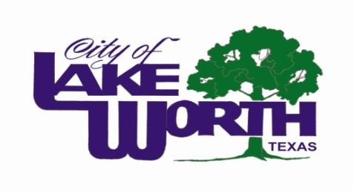
Whereas, emergency medical services (EMS) is a vital public service; and
Whereas, access to quality emergency care dramatically improves the survival and recovery rate of those who experience sudden illness or injury; and
Whereas, EMS plays a critical role in public outreach and injury prevention, and is evolving in its role as an important member of the healthcare community; and
Whereas, personnel from MedStar and Lake Worth Fire and Lake Worth Police Departments stand ready to provide compassionate, lifesaving care to those in need 24 hours a day, seven days a week; and
Whereas, emergency medical responders are supported by emergency medical dispatchers, educators, administrators, researchers, emergency nurses, emergency physicians and others; and
Whereas, the members of EMS teams, both career and volunteer, engage in thousands of hours of specialized training and continuing education to enhance their lifesaving skills; and
Whereas, it is appropriate to recognize the value and the accomplishments of EMS practitioners by designating Emergency Medical Services Week.
Now, therefore, I, Walter Bowen, Mayor of the City of Lake Worth, in recognition of this event do hereby proclaim the week of May 18-24, 2014 as “Emergency Medical Services Week” with the theme “EMS: Dedicated. For Life.” I encourage the community to observe this week with appropriate programs, ceremonies, and activities.
Proclaimed this 13th day of May 2014.

Walter Bowen, Mayor

