PROCLAMATION from the
Office of the Mayor
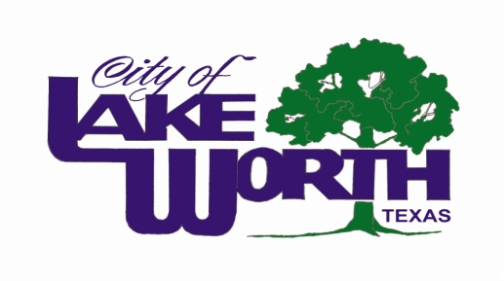
WHEREAS, October serves as National Disability Employment Awareness Month and Goodwill Industries of Fort Worth is the non-profit leader in helping people with disabilities achieve maximum independence in their communities around Tarrant County; and,
WHEREAS, Goodwill Industries of Fort Worth provides an extensive variety of programs and services for people with disabilities and/or disadvantages to be self-sufficient citizens, serving 42,768 people in 2013 in Tarrant County and surrounding areas; and,

WHEREAS, 93% of all revenue generated by Goodwill Industries of Fort Worth goes toward an extensive variety of job training and placement services for disabled and/or disadvantaged individuals seeking to be self-sufficient citizens in Tarrant County; and,
WHEREAS, based on the vision of founder Edgar J. Helms in 1902, Goodwill Industries of Fort Worth believes in a hand up, not a hand out, and that lives of dependence can be transformed into lives of independence through the power of work; and,
WHEREAS, Goodwill Industries International Inc. is the largest employer of people with disabilities in the world, creating a global effort to helping people with disabilities, NOW THEREFORE:
I, Walter Bowen, Mayor of the City of Lake Worth, and on behalf of the Lake Worth City Council, do hereby proclaim October 14, 2014, as

Goodwill Industries of Fort Worth
Helping People With Disabilities Day

in the City of Lake Worth.

Walter Bowen, Mayor

