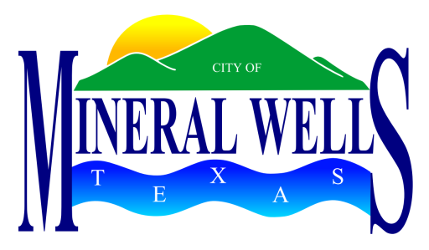

PROCLAMATION

WHEREAS, the Medal of Honor is the highest military decoration awarded by the United States Government and is bestowed by the President, in the name of Congress, upon members of the armed forces who distinguish themselves through conspicuous gallantry and intrepidity at the risk of his or her life above and beyond the call of duty while engaged in an action against an enemy of the United States; and

WHEREAS, Camp Wolters and Fort Wolters, located in Mineral Wells, Texas, were training facilities for the US Army at various times beginning in 1927 to 1975; and

WHEREAS, fourteen men who received Medal of Honor citations, received some of their training from these two sites and will be honored on this day in ceremonies at Fort Wolters Historical Park; and

WHEREAS, six of the recipients, who received their training from Camp Wolters, were: 1st Lieutenant Charles L. Thomas, 1st Lieutenant Eli L. Whiteley, 2nd Lieutenant Audie L. Murphy, Staff Sergeant Edward A. Carter, Jr., 1st Lieutenant Vernon Baker, and 1st Lieutenant Jack L. Knight; and

WHEREAS, eight of the recipients, who received their training from Fort Wolters, were: Chief Warrant Officer Michael J. Novosel, Major Patrick H. “Pat” Brady, Chief Warrant Officer Frederick Edgar Ferguson, Captain Jon E. Swanson, Major William E. Adams, 1st Lieutenant James M. Sprayberry, Captain Ed “Too Tall” Freeman and Staff Sergeant Joe R. Hooper.

NOW, THEREFORE, I, Mike Allen, Mayor of the City of Mineral Wells, do hereby proclaim March 23, 2013 as
Medal of Honor Day
in Mineral Wells and with this seal appreciate the recipients who passed through the doors of Camp Wolters or Fort Wolters.

Given under my hand and seal of office this 23rd day of March, 2013.

____________________________________
Mike Allen, Mayor

