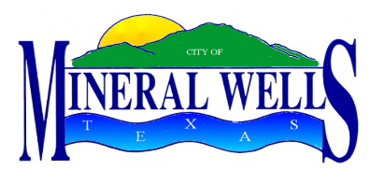

PROCLAMATION

WHEREAS, today’s society is finding more citizens involved in motorcycling on the roads of our country; and

WHEREAS, motorcyclists are roughly unprotected and therefore more prone to injury or death in a crash than other vehicle drivers; and

WHEREAS, campaigns have helped inform riders and motorists alike on motorcycle safety issues to reduce motorcycle related risks, injuries, and, most of all, fatalities, through a comprehensive approach to motorcycle safety; and

WHEREAS, it is the responsibility of all who put themselves behind the wheel, to become aware of motorcyclists, regarding them with the same respect as any other vehicle traveling the highways of this country; and it is the responsibility of riders and motorists alike to obey all traffic laws and safety rules; and

WHEREAS, all citizens of our community need to become aware of the inherent danger involved in operating a motorcycle, and for riders and motorists alike to give each other the mutual respect they deserve.

NOW, THEREFORE, I, Mike Allen, Mayor of the City of Mineral Wells, do hereby proclaim the month of May as
Motorcycle Safety and Awareness Month
Further, I urge all residents to do their part to increase safety and awareness in our community.

Given under my hand and seal of office this 20th day of May, 2014.

____________________________________
Mike Allen, Mayor

