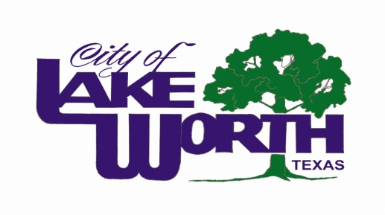Mayors Day of Recognition for National Service

WHEREAS, service to others is a hallmark of the American character, and central to how we meet our challenges; and

WHEREAS, the nation’s mayors are increasingly turning to national service and volunteerism as a cost-effective strategy to meet city needs; and,

WHEREAS, AmeriCorps and Senior Corps address the most pressing challenges facing our cities and nation, from educating students for the jobs of the 21st century and supporting veterans and military families to preserving the environment and helping communities recover from natural disasters; and

WHEREAS, national service expands economic opportunity by creating more sustainable, resilient communities and providing education, career skills, and leadership abilities for those who serve; and

WHEREAS, national service participants serve in more than 70,000 locations across the country, bolstering the civic, neighborhood, and faith-based organizations that are so vital to our economic and social well-being; and

WHEREAS, national service participants increase the impact of the organizations they serve with, both through their direct service and by recruiting and managing millions of additional volunteers; and,

WHEREAS, national service represents a unique public-private partnership that invests in community solutions and leverages non-federal resources to strengthen community impact and increase the return on taxpayer dollars; and,

WHEREAS, AmeriCorps members and Senior Corps volunteers demonstrate commitment, dedication, and patriotism by making an intensive commitment to service, a commitment that remains with them in their future endeavors; and

WHEREAS, the Corporation for National and Community Service shares a priority with mayors nationwide to engage citizens, improve lives, and strengthen communities; and is joining with mayors across the country to support the Mayors Day of Recognition for National Service on April 1, 2014.

THEREFORE, BE IT RESOLVED that I, Walter Bowen, Mayor of the City of Lake Worth, do hereby proclaim April 1, 2014, as National Service Recognition Day, and encourage residents to recognize the positive impact of national service in our city, to thank those who serve; and to find ways to give back to their communities.

____________________
Walter Bowen, Mayor

