PROCLAMATION from the
Office of the Mayor
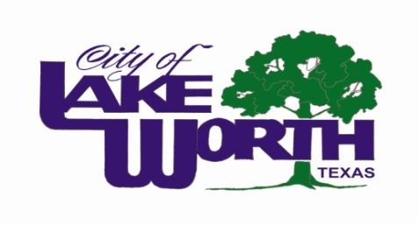

WHEREAS, the mission of the public schools is to meet the diverse educational needs of all children and to empower them to become competent, productive contributors to a democratic society and an ever-changing world; and

WHEREAS, local school board members are committed to children and believe that all children can be successful learners and that the best education is tailored to the individual needs of the child; and

WHEREAS, local school board members work closely with parents, educational professionals, and other community members to create the educational vision we want for our students; and

WHEREAS, local school board members are responsible for ensuring the structure that provides a solid foundation for our school system; and

WHEREAS, local school board members are strong advocates for public education and are responsible for communicating the needs of the school district to the public and the public’s expectations to the district;

NOW, THEREFORE, I, Mayor Walter Bowen, do hereby declare my appreciation to the members of the Lake Worth Independent School Board and proclaim the month of January 2015, as

“School Board Recognition Month”

in Lake Worth, Texas. I urge all citizens to join me in recognizing the dedication and hard work of local school board members and in working with them to mold an education system that meets the needs of both today’s and tomorrow’s children.

In official recognition whereof, I hereby affix my signature this 19th day of January, 2015.

_______________________________
Mayor Walter Bowen

