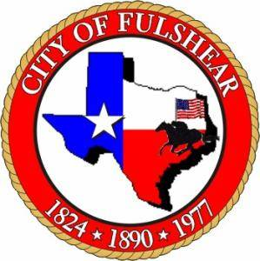
Proclamation
WHEREAS, today 1.6 billion people live inadequate shelter around the world and 1 billion of those live in slums.
WHEREAS, about one in four people live in conditions that harm their health, safety, prosperity and opportunities and one in 300 Fort Bend County residents are either homeless, live in substandard, or unaffordable housing

WHEREAS, adequate housing is vitally important to the health of the world’s economies, communities and populations And , home ownership is a form of wealth accumulation through equity and forced savings from mortgage repayment.

WHEREAS, good housing attracts economic investment and development., and contributes to thriving school systems, community organization and civic activism And, safe homes and neighborhoods help to build social stability and security.

WHEREAS, every 5-1/2 minutes, Habitat for Humanity serves a family in need of better housing, In 2012 eight homes were built in Fort Bend County

WHEREAS, about 1 million volunteers work with Habitat for Humanity every year worldwide, And over 2,000 Fort Bend citizens each year donate over 30,000 hours of volunteer time toward building homes for their fellow citizens in Fort Bend County

WHEREAS, Fort Bend Habitat for Humanity is one of the 1,500 Habitat communities in the United States, and in more than 70 countries worldwide, from Argentina to Zambia, that comprise Habitat for Humanity International.

WHEREAS, Fort Bend Habitat for Humanity has housed 71 families, serving more than 350 people, since its founding in 1992.

WHEREAS, if we are to succeed in the fight against poverty housing, we must support the expansion of housing both as policy and as practice.

WHEREAS, on World Habitat Day, the first Monday of October, Fort Bend Habitat for Humanity joins the United Nations and organizations around the world in raising awareness, education and mobilizing individuals and communities to take action on the current global housing crisis.

NOW, THEREFORE, we, The City Council of Fulshear, Texas do hereby proclaim October 7, 2013 as

“WORLD HABITAT DAY in FULSHEAR, Texas”

and commend its observance to all citizens in celebration of its significance and impact on our community
_________________________________
Thomas C. Kuykendall, Jr. –Mayor

Attest:
__________________________________
D. (Diana) Gordon Offord – City Secretary

