PROCLAMATION from the
Office of the Mayor
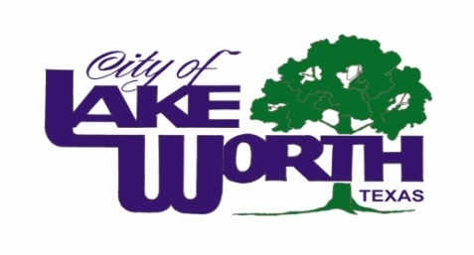
WHEREAS, more than six hundred local chambers of commerce in Texas distinguish themselves as the voice of business in our state; and

WHEREAS, the work accomplished by those local chambers has benefited our state through their economic development, tourism promotion and community development programs; and

WHEREAS, the local chambers of commerce unceasingly promote their community for quality growth and development; and

WHEREAS, the business community, represented through local chambers of commerce, has been a driving force in fostering enhanced educational opportunities, infrastructure improvements, leadership development, the creation of jobs, and a positive vision of the future; and

WHEREAS, the chamber of commerce community in Texas has sought to achieve successful results for our state in a cooperative spirit with other organizations; and

WHEREAS, the Northwest Tarrant Chamber of Commerce has proudly represented the business community in Lake Worth and Northwest Tarrant County for twenty-nine years; and

WHEREAS, the Northwest Tarrant Chamber has been a strong partner with the City of Lake Worth in endeavors to promote and develop our local business community;

NOW THEREFORE, BE IT PROCLAIMED THAT THE LAKE WORTH CITY COUNCIL PROCLAIMS THE WEEK OF OCTOBER 14-18, 2013 AS
CHAMBER OF COMMERCE WEEK in Lake Worth, Texas.

PROCLAIMED THIS 22nd DAY OF OCTOBER, 2013.

________________________
Walter Bowen, Mayor

