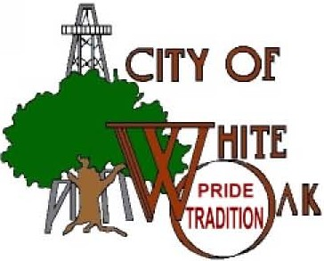

PROCLAMING OCTOBER 16, 2011 AS “EMMANUEL BAPTIST CHURCH DAY” ON THEIR 75TH ANNIVERSARY

WHEREAS, beginning in the early 1930’s as an oil boom church, in October 1936, Emmanuel Baptist Church became a member of the Baptist General Convention when the membership charter was signed by twenty-seven church members; and

WHEREAS, Emmanuel Baptist Church came about by several mothers that wanted their children to be churched and with the help of the First Baptist Church of Gladewater and Preacher John Keys who would commute weekly from Baylor University and bring Sunday school literature; and

WHEREAS, Emmanuel Baptist Church was deeded the surface rights to the plot of land where the current church building is located in 1937 and a small frame structure was built. Then in 1966 a new sanctuary was built. As membership grew, a parsonage and Education Building was added in 1970, only to succumb to a busted sewer pipe Thanksgiving Weekend in the year 2000. By working together, the church members were in their rebuilt sanctuary by the next Thanksgiving holiday; and

WHEREAS, Emmanuel Baptist Church exists to meet the needs of its members and to the communities to which they belong. They worship together as a community of believers and support one another’s values and beliefs in the One True God; and

WHEREAS, today, October 16, 2011 celebrates the 75th anniversary of Emmanuel Baptist Church, located in White Oak, Texas and is still committed as much today as it was in the 1930’s to help nurture the faith of members and to be a good neighbor to those in need;

NOW THEREFORE, to recognize and commemorate the 75th anniversary of Emmanuel Baptist Church, I, Rick May, Mayor of the City of White Oak, hereby proclaim October 16, 2011, as “Emmanuel Baptist Church Day.”

Witness My hand this 16th day of October, 2011

Mayor Richard May

