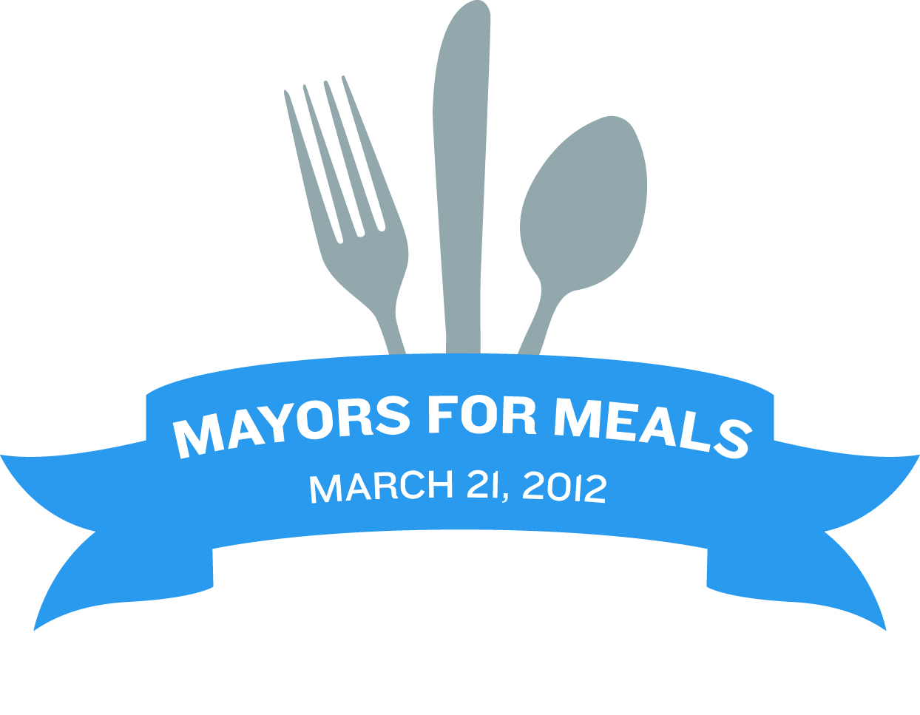
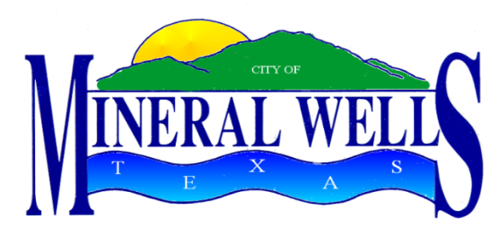

PROCLAMATION

WHEREAS, Meals on Wheels of Palo Pinto County, Texas delivers hot meals daily to those who are homebound and unable to prepare food for themselves; and

WHEREAS, volunteer drivers for Meals On Wheels of Palo Pinto County are the backbone of the program and provide nutritious meals, caring concern and attention to their welfare; and

WHEREAS, the Meals On Wheels Association of America established the National March For Meals Campaign in March 2002 to recognize the historic month, the importance of Older Americans Act Senior Nutrition Programs and raise awareness about senior hunger in America; and

WHEREAS, in 2012, “March for Meals” includes a component called “Mayors for Meals” which is a designated day on which American mayors across the country will show their support for their city’s Meals on Wheels program, by delivering meals to homebound seniors and individuals with disabilities; and

WHEREAS, the Mayor of the City of Mineral Wells wishes to call upon the citizens of Mineral Wells to volunteer service and/or make a donation to support the local Meals on Wheel effort.

NOW, THEREFORE, be it proclaimed that on Wednesday, March 21, 2012 Mayor Mike Allen of the City of Mineral Wells will participate in meal delivery and this date will be known in Mineral Wells, Texas as

“Mayors for Meals Day”

Given under my hand and seal of office this 21st day of March, 2012.

______________________________
Mike Allen, Mayor

