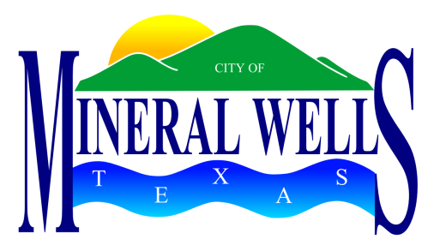

C:\Users\pgustin\AppData\Local\Microsoft\Windows\Temporary Internet Files\Content.IE5\3RV3WM1B\MC900346813[1].wmf**PROCLAMATION**

**WHEREAS,** the National Day of Prayer Task Force, a project of the National Prayer Committee, is dedicated to calling America back to God; and

**WHEREAS,** the National Day of Prayer is observed on the first Thursday of May each year; and

**WHEREAS,**  the theme for 2014 is “ONE VOICE, UNITED IN PRAYER”; and

**WHEREAS,**  individuals, corporately and individually, need to place their faith in the unfailing character of their Creator, who is sovereign over all governments, authorities, and men; and

**WHEREAS,**  with one mind and one voice, we may glorify God; and

**WHEREAS,** there is power in prayer, we can find hope and comfort in the grace and guidance of a loving God.

**NOW, THEREFORE,** I, Mike Allen, Mayor of the City of Mineral Wells, do hereby proclaim Thursday, May 1, 2014

**A DAY OF PRAYER**

for our City of Mineral Wells.

Given under my hand and seal of office this 1st day of May, 2014.

____________________________________

Mike Allen, Mayor