PROCLAMATION from the
Office of the Mayor
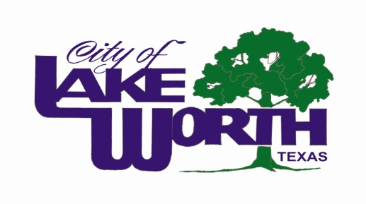
WHEREAS, Congress and the President of the United States have established the second week of April as National Telecommunicators Week; and

WHEREAS, when an emergency occurs, the prompt response of police officers, firefighters and paramedics is critical to the protection of life and preservation of property, and the City of Lake Worth Public Safety Telecommunicators are the single vital link between first responders and persons seeking immediate relief during an emergency; and

WHEREAS, the work of these “unseen first responders” is invaluable in emergency situations; and

WHEREAS, each dispatcher has exhibited compassion, understanding, and professionalism during the performance of their job in the past year.

NOW THEREFORE, I, Walter Bowen, Mayor of the City of Lake Worth, and on behalf of the entire City Council, do hereby proclaim the week of April 13-19, 2014 as:
NATIONAL PUBLIC SAFETY
TELECOMMUNICATORS WEEK

In the City of Lake Worth, Texas, and encourage the citizens of Lake Worth to express their appreciation to the Lake Worth Public Safety Telecommunicators for their diligence and professionalism in keeping our city and citizens safe.

PROCLAIMED this the 8th day of April, 2014.

Walter Bowen, Mayor

