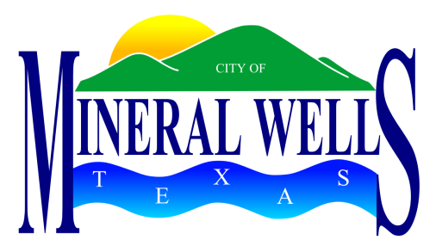
PROCLAMATION

WHEREAS, The Palo Pinto County Livestock Association was formed in the mid-1930s to promote the livestock industry in Palo Pinto County as a respected way of life for citizens of all ages; and

WHEREAS, The Palo Pinto County Livestock Association held its first Pro Rodeo in 1937 and has continually sponsored the Annual Rodeo since that date; and

WHEREAS, The Palo Pinto County Livestock Association’s PRCA/WPRA All-American Series Pro Rodeo for 2014 will be their 77th Annual Event; and

WHEREAS, The Palo Pinto County Livestock Association members are to be congratulated for their efforts and services to the citizens of Mineral Wells and Palo Pinto County; and

WHEREAS, The Palo Pinto County Livestock Association’s 77th Annual Pro Rodeo is in the second week of May, 2014.

NOW, THEREFORE, I, Mike Allen, Mayor of the City of Mineral Wells, do hereby proclaim the second week of May, 2014 as

Pro Rodeo Week

Given under my hand and seal of office this 11th day of April, 2014.

_____________________________________
Mike Allen, Mayor

